Jetzen Case Study

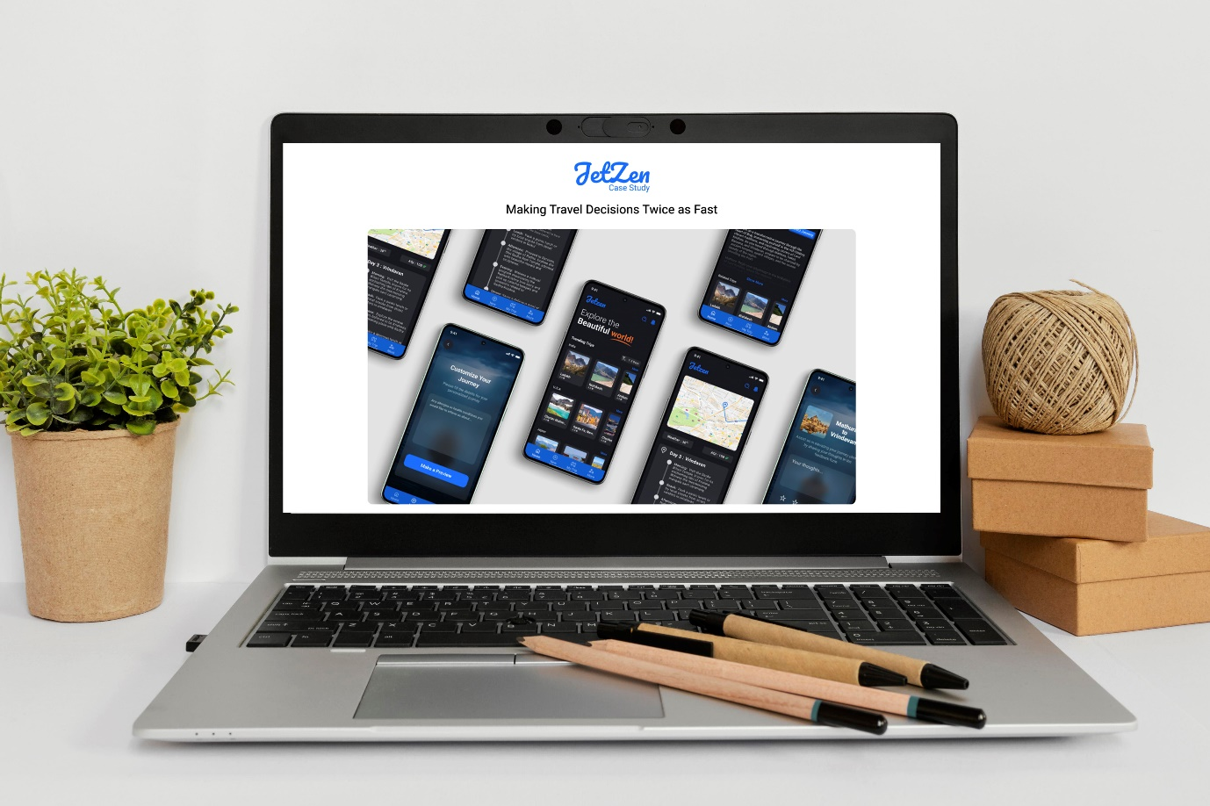

Description:

Jetzen is a revolutionary travel planning application that aims to transform the way individuals plan and experience their journeys. Unlike traditional travel platforms, Jetzen offers a seamless and comprehensive approach to trip planning, integrating innovative features and AI-driven technology to streamline the entire process.

Key Features:

1. AI-Powered Itinerary Planning: Jetzen utilizes advanced artificial intelligence algorithms to generate personalized travel itineraries based on user preferences, budget constraints, and destination interests. The AI continuously learns and adapts to user feedback, ensuring that each itinerary is tailored to meet the unique needs of the traveler.

2. Accommodation Booking: Users can effortlessly search for and book accommodations directly within the Jetzen app. With access to a vast database of hotels, resorts, and vacation rentals, Jetzen provides users with real-time availability, pricing information, and reviews to facilitate informed decision-making.

3. Dining Recommendations: Jetzen offers curated dining recommendations based on user preferences, cuisine preferences, and dietary restrictions. Whether users are seeking fine dining experiences or local eateries, Jetzen ensures that they discover culinary delights that suit their taste buds.

4. Real-Time Updates: Stay informed throughout your journey with real-time updates on flight statuses, weather forecasts, and local events. Jetzen keeps travelers informed and prepared for any changes or unexpected events, ensuring a smooth and stress-free travel experience.

5. Feedback and Customization: Jetzen values user feedback and allows users to provide input on their travel experiences. Whether it's rating accommodations, sharing dining reviews, or suggesting improvements to the itinerary, Jetzen prioritizes user satisfaction and continuously refines its services based on user input.

Overall, Jetzen empowers travelers to plan their dream vacations with ease, efficiency, and peace of mind. With its intuitive interface, comprehensive features, and commitment to user satisfaction, Jetzen is revolutionizing the way people explore the world.

Link: <https://www.figma.com/proto/snMeWr2qvBHMYVRGaIpEZE/redesign?page-id=415%3A11789&type=design&node-id=435-11876&viewport=202%2C597%2C0.27&t=8cWn8ISlqZLrWqdh-1&scaling=min-zoom&starting-point-node-id=435%3A11876&mode=design>